

**Power BI for Civic Data 101 – Climate Change**

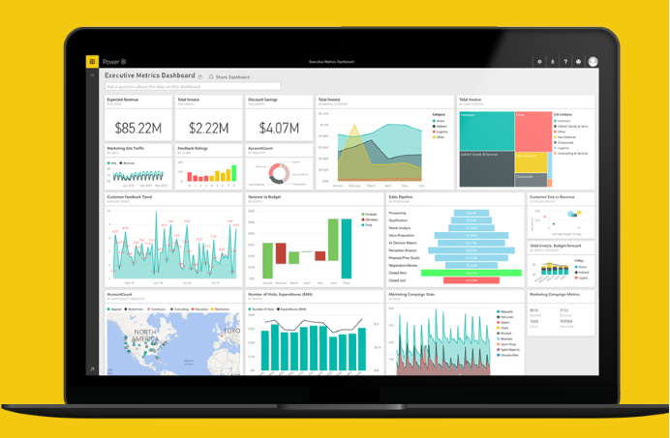

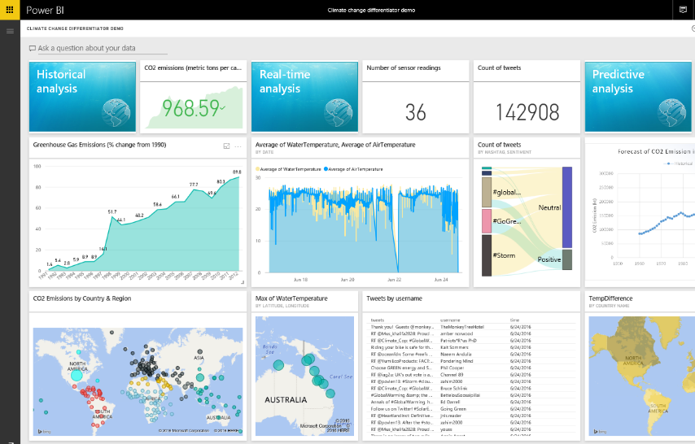

# Contents

[Contents 2](#_Toc455678238)

[About this demo 3](#_Toc455678239)

[Prerequisites 4](#_Toc455678240)

[Power BI Desktop - Climate Change 6](#_Toc455678241)

[Conclusion 25](#_Toc455678242)

# About this demo

This Power BI demo is intended to provide you with a tour of the main components and features of Power BI. You will start this demo “from scratch”, with a publicly available data set. Using Power BI Desktop, you will connect to the data set and shape it to your needs. You will explore and visualize the data in Power BI Desktop and create interactive reports, that you can publish and share with others. In the Power BI service, you will quickly create a dashboard from your existing report and use natural language query to find more insights. Finally, you will see how you can take your data and insights with you, using the Power BI mobile app for your device.

The scenario for this demo is about Climate Change and based on a public data set from the World Bank organization.

**Power BI features showcased in this demo:**

* + From data to insights in 5 minutes
  + Live connectivity to data sources
  + Powerful data query and transformation capabilities
  + Impactful reports with interactive visualizations
  + Natural language query
  + Mobile apps

**Demo Scenario**

The scenario for this demo is based on a data set from the World Bank Group (WBG) on climate change. The data is publicly available at [www.worldbank.org](http://www.worldbank.org). Climate change is an important topic of our time, for people around the world. Using this public data set, we can find interesting insights that help us understand more about this complex topic. In this demo, you will examine the development of greenhouse gas emissions and find insights into the following topics:

* + Greenhouse gas (in particular CO2) emissions since 1990
  + Sources of electricity by country
  + Forest areas by geography

# Prerequisites

| Prerequisite | Screenshot |
| --- | --- |
| 1. **Prerequisite 1**: You will need a Power BI account for this demo. If you do not have an account, you can sign up for free at <http://powerbi.com> |  |
| 1. **Prerequisite 2**: You will need Power BI Desktop installed on your machine.   Visit <http://powerbi.microsoft.com/desktop> to install the latest update of Power BI Desktop. |  |

|  |  |
| --- | --- |
| 1. **Prerequisite 3: Power BI Mobile App**   You will need the Power BI mobile app installed on your device (Windows, iOS, Android).  Visit <http://powerbi.microsoft.com/en-us/mobile/> or the app store for your device to download the latest version of the Power BI mobile app. |  |

# Power BI Desktop - Climate Change

| Steps | Screenshot |
| --- | --- |
| 1. In Power BI Desktop with the blank report page, from the **Home** tab, select **Get Data** – **Web**. |  |
| 1. You will be prompted to enter a web page URL. 2. Leave the dialog open; you will find the URL in the following steps and come back to it. |  |
| 1. Switch to your browser window. 2. Navigate to [www.worldbank.org](http://www.worldbank.org) 3. Select **Data** from the top navigation. |  |
| 1. On the **Data** page, type **Climate** in the search box. 2. Select **Climate Change** from the list of suggested terms. |  |
| 1. On the **Climate Change** page, scroll down and click on **Download**. |  |
| 1. You will see three download options: **Excel**, **XML**, and **CSV**. 2. Right-click on **Excel**, then select **Copy Shortcut**. |  |
| 1. Switch back to your Power BI Desktop window. 2. Paste the shortcut into the **URL** field of the **From Web** dialog. 3. Click on **OK**. |  |
| 1. The **Navigator** dialog will appear. 2. Select the **Data** and **Metadata – Countries** data sets. 3. Click on **Edit**. 4. Power BI Desktop will show the data in the **Query Editor**. |  |
| 1. Below **Queries [2]**, select the **Metadata – Countries** query. 2. Expand the menu in the top left corner of the data table and select **Use First Row As Headers**. |  |
| 1. Below **Queries [2]**, select the **Data** query. 2. Expand the menu in the top left corner of the data table and select **Remove Top Rows**. 3. Remove the top **3** rows. |  |
| 1. Expand the menu in the top left corner of the data table and select **Use First Row As Headers**. |  |
| 1. Select all the year columns (**1990** to **2015**) of the data table. Use the **SHIFT** key to multi-select. 2. Right-click on one of the column headers and select **Unpivot Columns**. |  |
| 1. Right-click on the new column titled **Attribute** and select **Rename**. 2. Rename the column to **Year**. |  |
| 1. Click on the column header **Indicator Name** to select the entire column. 2. From the **Transform** ribbon, select **Pivot Column**. 3. Select **Value** to pivot the column on. |  |
| 1. From the **Home** ribbon, select **Close** **& Apply** to apply the query changes. |  |
| 1. After the query changes have been applied to the data, switch to the **Relationships** view in Power BI Desktop. 2. Notice that Power BI has auto-created a relationship between the two data tables on the **Country Code** field. |  |
| 1. Switch to the **Report** view in Power BI Desktop. You should see a blank report page. 2. In the **Fields** pane on the right, expand the fields in the **Data** table. 3. Select the field **CO2 emissions (kt)**. You can hover over a field or resize the Fields pane to see the full names. 4. A bar chart will appear as the default visualization. |  |
| 1. Change the visualization to **Card**. 2. Move the card to the top left area of the report page. |  |
| 1. Drag and drop the field **Year** into **Visual level filters**. 2. Select **2011** in the list of years. |  |
| 1. Click on an empty area on the report page. 2. Select the fields **CO2 emissions (kt)** **and Year** from the **Data** table. 3. Change the visualization type to **Area chart**. 4. Resize the chart and move it next to the card visualization. |  |
| 1. Using the menu (**…**) at the top right of the visualization, select **Sort By Year A->Z**. |  |
| 1. Click on an empty area on the report page, below the card visual. 2. Select the field **Region** from the **Metadata – Countries** table. 3. Select the field **CO2 Emissions (kt)** from the **Data** table. 4. Change the visualization into a **Treemap**. 5. Resize and move the visualization to the bottom left area of the report page. |  |
| 1. Drag and drop the field **Region** from the **Metadata – Countries** data table to **Report level filters**. 2. **Select All**, then uncheck **Blank** to filter out any data records that do not have a region assigned. |  |
| 1. Click on region **East Asia & Pacific** in the treemap to show the interactivity with the other two charts. 2. Click on region **East Asia & Pacific** again to clear the selection. |  |
| 1. Select the treemap visualization. 2. Change the visualization into a **Stacked Bar Chart**. |  |
| 1. Drag the field **Forest area (sq. km)** into the **Color saturation** property. |  |
| 1. Using the menu (**…**) at the top right of the visualization, select **Sort By CO2 emissions (kt) Z->A**. |  |
| 1. Switch to the **Format** menu (pencil icon) for the bar chart visual. 2. Expand the **Data colors** section. 3. Change the **Minimum** and **Maximum** values to a different color. |  |
| 1. Switch to the Fields menu (bars icon) for the bar chart visual. 2. Drag the field **Country Name** below **Region** into the **Group** area. |  |
| 1. Click on the drill mode arrow at the top right of the visual. 2. Click on **East Asia & Pacific** to see all the countries that are part of that region. 3. Click on the arrow up to drill up to the region level. |  |
| 1. Click on an empty area on the report page. 2. In the **Visualizations** pane, choose **Map**. |  |
| 1. Drag and drop the field **Country Name** from the **Data** table to the **Location** property. 2. Drag and drop the field **CO2 emissions (kt)** from the **Data** table to the **Size** property 3. Drag and drop the field **Region** from the **Metadata – Countries** table to the **Legend** property. |  |
| 1. Resize and rearrange the visuals as shown. 2. Save the file as **ClimateChangeDemo.pbix** |  |
| 1. On the ribbon, select **Publish.** 2. When prompted, sign in to the Power BI service. |  |
| 1. Select **My Workspace** as destination, then click **Publish**. |  |
| 1. Once the file has been published, you can open it in the Power BI service, or you can select **Get Quick Insights** to see this amazing feature. 2. Click on **Open ‘ClimateChangeDemo.pbix’ in Power BI**. 3. When prompted, sign in to Power BI with your account. |  |
| 1. In the Power BI service, under **Reports**, select the **ClimateChangeDemo** report. |  |
| 1. Use the pin icon on the **CO2 emissions (kt)** card to pin it to the dashboard. 2. Choose **New dashboard** and name the new dashboard **Climate Change Demo**. |  |
| 1. Pin the remaining visuals to the existing dashboard **Climate Change Demo**. |  |
| 1. Under **Dashboards**, select the **ClimateChangeDemo** report. |  |
| 1. Place the cursor in the field **Ask a question about your data** at the top of the dashboard. 2. Enter   **total greenhouse**   1. Accept the suggested term   **total greenhouse gas emissions (% change from 1990)**   1. Add to the question   **total greenhouse gas emissions (% change from 1990)**  **) by year as line for usa**   1. Optional: ask the audience to name another country (interesting examples include China, Canada, France, Qatar, Switzerland). 2. Pin the chart to the dashboard. |  |
| Note: You can use your Windows phone, iPhone or Android phone for most of this demo.  Included below are the steps for an iPhone.   1. Launch the **Power BI** app on your iPhone. 2. **Sign in** with your Microsoft Power BI account. | C:\Users\Shashank\AppData\Local\Microsoft\Windows\INetCacheContent.Word\IMG_7126.png |
| 1. Select the **Climate Change Demo** dashboard and scroll through the visualizations. |  |
| 1. Scroll through the tiles. |  |
| 1. Rotate your phone into landscape mode. 2. Rotate your phone back into portrait mode. 3. Tap on the **CO2 emissions (kt)** chart. |  |
| 1. Interact with the chart by moving the vertical line from left to right. |  |
| 1. Annotate the chart by highlighting a drop or a spike. 2. You can share the chart with your annotations easily by clicking on the share button on the top right hand side. 3. Go back to the main dashboard. |  |

# Conclusion

We hope you enjoyed this brief tour of Power BI and its capabilities to connect to all sorts of data, shape and visualize data, and publish the results to the Power BI service. You saw how easy it is with Power BI to build reports and dashboards “from scratch”. Using Power BI Desktop, you connected to a public data set and shaped it to your needs. You explored and visualized the data in Power BI Desktop and created an interactive report, that you published and shared with others. In the Power BI service, you quickly created a dashboard from the report and used natural language query to find more insights. Finally, you saw how you can take your data and insights with you, using the Power BI mobile app for your device.

©2016 Microsoft Corporation. All rights reserved.

By using this demo/lab, you agree to the following terms:

The technology/functionality described in this demo/lab is provided by Microsoft Corporation for purposes of obtaining your feedback and to provide you with a learning experience. You may only use the demo/lab to evaluate such technology features and functionality and provide feedback to Microsoft. You may not use it for any other purpose. You may not modify, copy, distribute, transmit, display, perform, reproduce, publish, license, create derivative works from, transfer, or sell this demo/lab or any portion thereof.

COPYING OR REPRODUCTION OF THE DEMO/LAB (OR ANY PORTION OF IT) TO ANY OTHER SERVER OR LOCATION FOR FURTHER REPRODUCTION OR REDISTRIBUTION IS EXPRESSLY PROHIBITED.

THIS DEMO/LAB PROVIDES CERTAIN SOFTWARE TECHNOLOGY/PRODUCT FEATURES AND FUNCTIONALITY, INCLUDING POTENTIAL NEW FEATURES AND CONCEPTS, IN A SIMULATED ENVIRONMENT WITHOUT COMPLEX SET-UP OR INSTALLATION FOR THE PURPOSE DESCRIBED ABOVE. THE TECHNOLOGY/CONCEPTS REPRESENTED IN THIS DEMO/LAB MAY NOT REPRESENT FULL FEATURE FUNCTIONALITY AND MAY NOT WORK THE WAY A FINAL VERSION MAY WORK. WE ALSO MAY NOT RELEASE A FINAL VERSION OF SUCH FEATURES OR CONCEPTS. YOUR EXPERIENCE WITH USING SUCH FEATURES AND FUNCITONALITY IN A PHYSICAL ENVIRONMENT MAY ALSO BE DIFFERENT.

**FEEDBACK**. If you give feedback about the technology features, functionality and/or concepts described in this demo/lab to Microsoft, you give to Microsoft, without charge, the right to use, share and commercialize your feedback in any way and for any purpose. You also give to third parties, without charge, any patent rights needed for their products, technologies and services to use or interface with any specific parts of a Microsoft software or service that includes the feedback. You will not give feedback that is subject to a license that requires Microsoft to license its software or documentation to third parties because we include your feedback in them. These rights survive this agreement.

MICROSOFT CORPORATION HEREBY DISCLAIMS ALL WARRANTIES AND CONDITIONS WITH REGARD TO THE DEMO/LAB, INCLUDING ALL WARRANTIES AND CONDITIONS OF MERCHANTABILITY, WHETHER EXPRESS, IMPLIED OR STATUTORY, FITNESS FOR A PARTICULAR PURPOSE, TITLE AND NON-INFRINGEMENT. MICROSOFT DOES NOT MAKE ANY ASSURANCES OR REPRESENTATIONS WITH REGARD TO THE ACCURACY OF THE RESULTS, OUTPUT THAT DERIVES FROM USE OF DEMO/ LAB, OR SUITABILITY OF THE INFORMATION CONTAINED IN THE DEMO/LAB FOR ANY PURPOSE.

**DISCLAIMER**

This demo/lab contains only a portion of new features and enhancements in Microsoft Power BI. Some of the features might change in future releases of the product. In this demo/lab, you will learn about some, but not all, new features.